**Re Assure API Internal Testing   
30/03/2020**

1)error coming on leaving start_date empty while creating a claim.

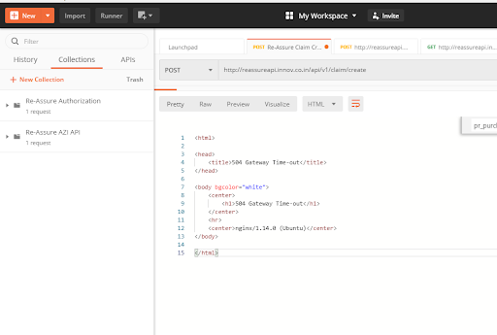

2) Error is coming for leaving End Date blank while creating claim.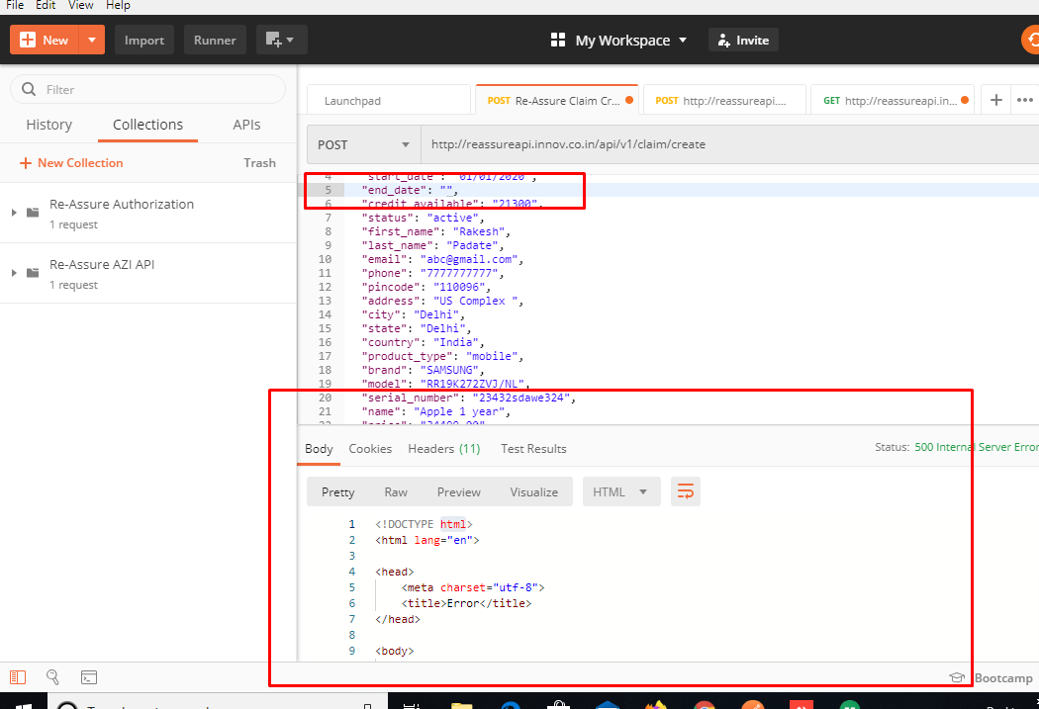  
  
3)Validation message for entering invalid Date in start date is not coming.

4) Status field can only take Active/Cancelled/Expired else remove the character limit from it.

5) For all the fields having Data types as Date-Time (purchase_date,loss_date,claim_creation_date,Earliest_start_permitted,expected_datetime_closure and due_date , If user )enters valid date time then error gets appear as below screenshot.  
  
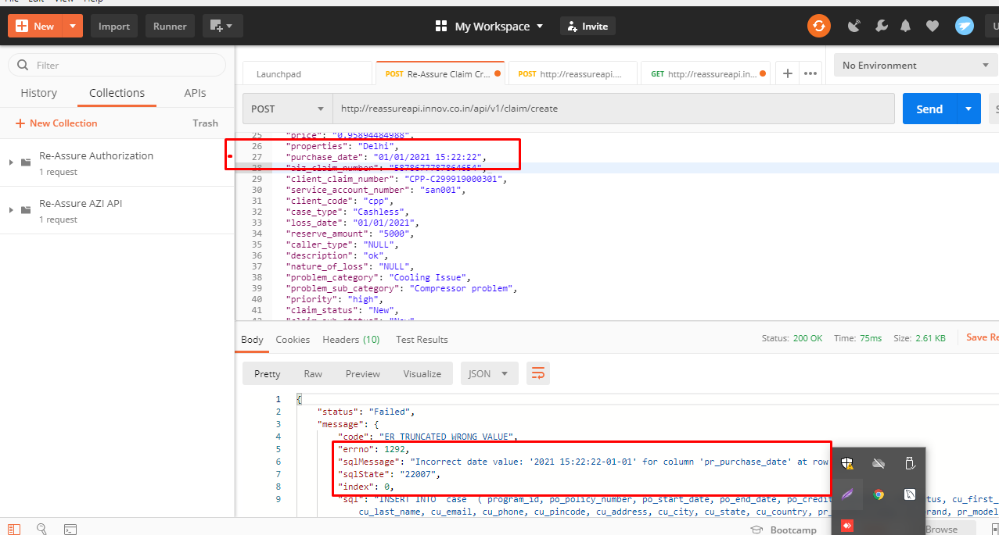

6) User is able to create claim by entering alphanumeric valium in AIZ claim number as per the API integration Document It can only take numbers .  
  
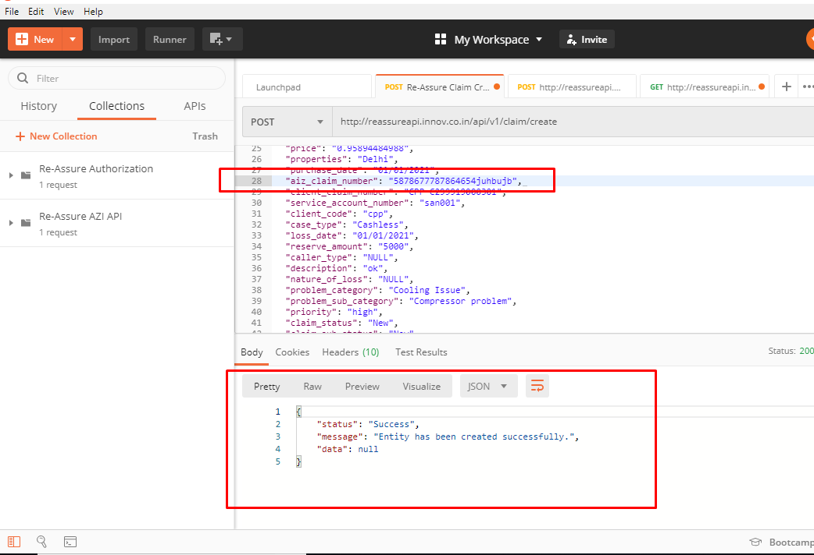

7) There is no validation appears for leaving Claim Status field blank. There should be a validation message for leaving it blank as its a mandatory field.

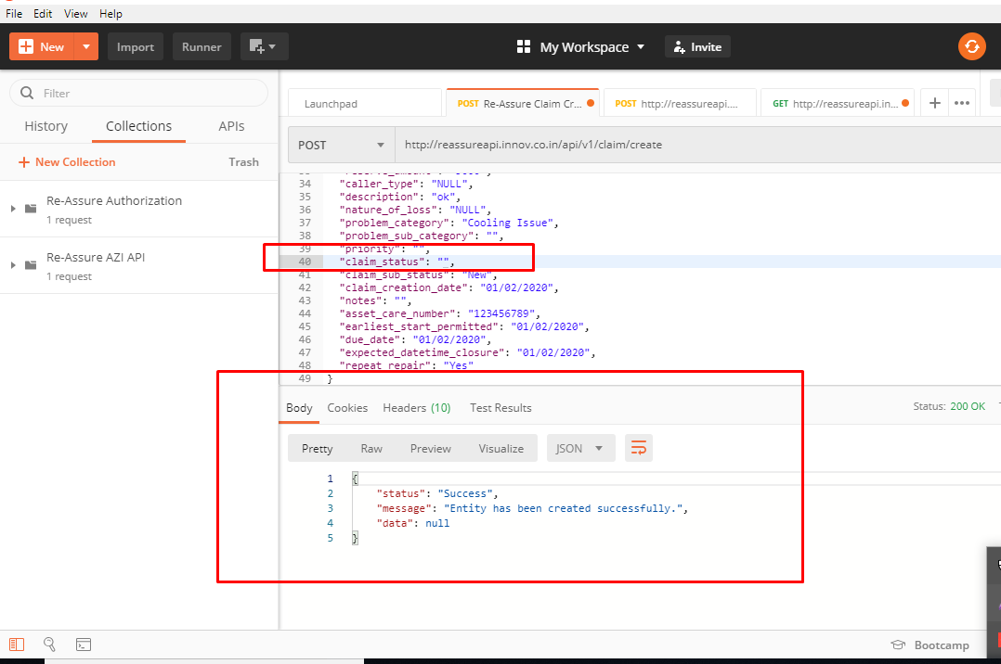

8) There is no validation appears for leaving

Claim Sub Status field blank. There should be a validation message for leaving it blank as its a mandatory field.

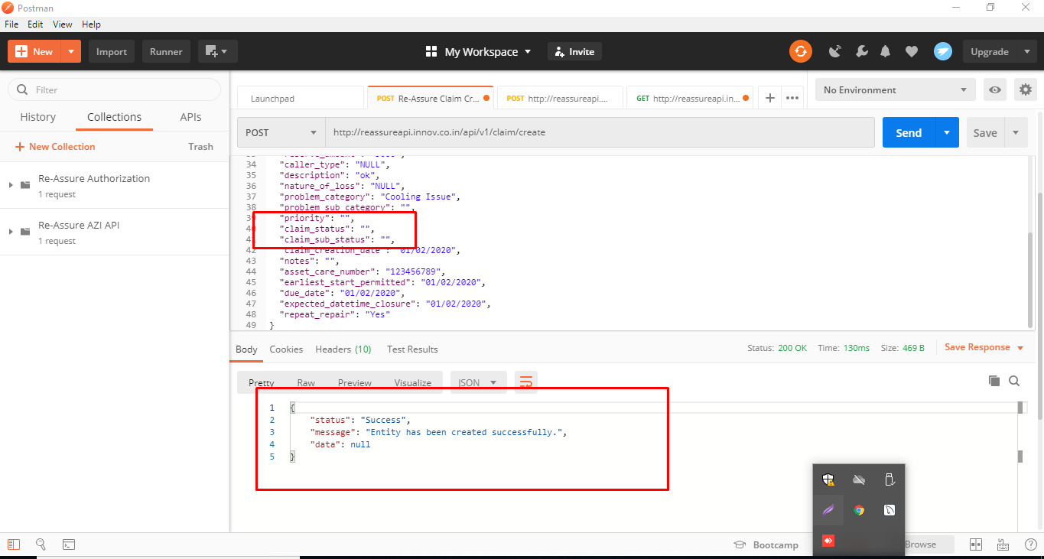

9) For leaving Claim creation date blank following error is coming please find below:  
504 Gateway Time-out

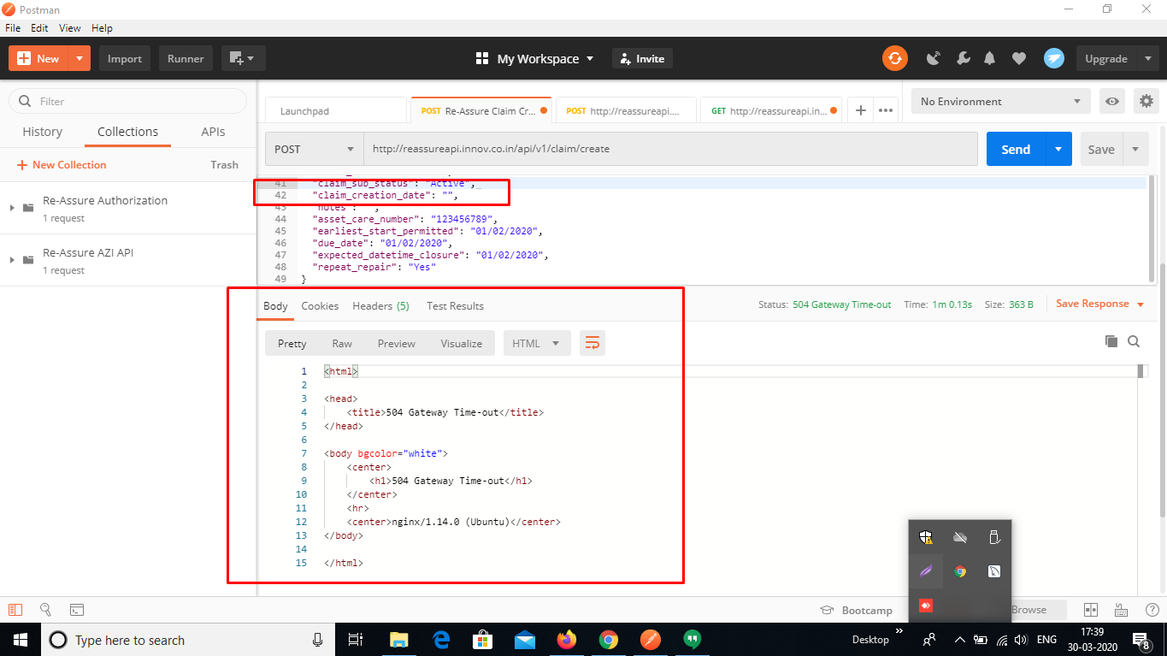

10)There is no validation appears for leaving

Earliest Start Permitted date field blank. There should be a validation message for leaving it blank as its a mandatory field.

